Definitions
A plot diagram is a tool that is commonly used to organize a story into certain segments. Once the parts of the plot diagram are identified, it is easier to analyze the content. A plot diagram also gives a common framework for analyzing and understanding written prose.
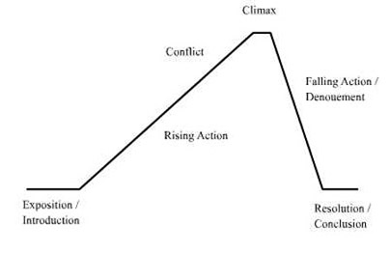

Exposition or Introduction
The exposition or the introduction introduces the characters, describes the setting and establishes the problem in the story.

Rising Action
The rising action is where the suspense builds and the problem gets worse and becomes more complicated. There are often multiple steps or parts in the rising action.

Climax
The climax is the turning point in the story. It is usually the most exciting part in the story and the part that makes the reader want to keep reading.

Falling Action or Denouement
The falling action are the events that happen after the climax that lead to a resolution or ending to the story.

Resolution or Conclusion
The resolution is the outcome of the story. It is how things end up or turn out for the characters.

